Newsletter
Issue 17

19 January 2024

Dear Parents and Carers,

Calshot
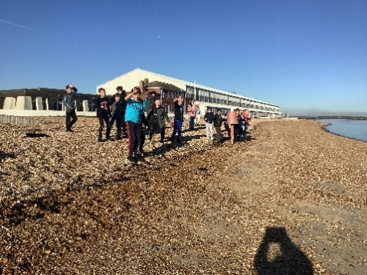
Year 6 have had a lovely week at Calshot. They have done lots of great activities. The weather on the first day was cold but very sunny and they managed to get to the beach. They have also had a go at skiing and rock climbing as well as lots of other exciting events. They have returned home today tired but having had a great time!

Year 2
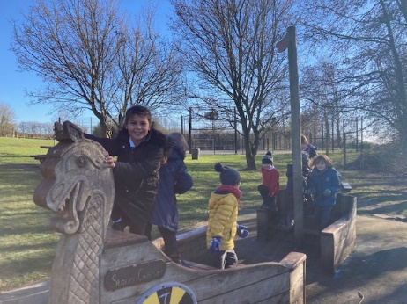
On Thursday Year 2 went for a walk as part of our Geography and Science learning. We followed routes we had been previously studying on local maps and we also looked for signs of winter. The sun was shining and it was so lovely to see the children having such fun chatting to each other as we walked. Before returning to school we visited Oliver’s Battery Recreation Ground where we checked on the trees that our School Councillors planted a little while ago. Then we played in the park which was great fun too!
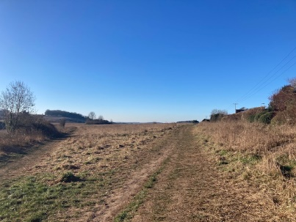
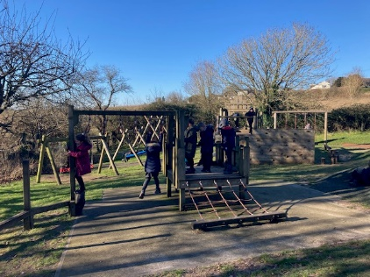
We are hoping to follow the same route again in the Spring/summer so we can compare the landscape and wildlife. We might have another play in the park too!

Change of Menu
There will be a change of menu for the Red option for Monday 22 January. The Red option will be Bubble Salmon Fishcake not Cottage pie. There is no change to the green option – meat free hotdog with diced potatoes.

Football Club
We have been approached by a football coach who is interested in running an after school football club for Years 3 and 4 (Girls and Boys). This will be run by a private company at a cost of £7.00 per child per week. If your child is in Year 3 or 4 and is interested please can you let the school office know so we can gauge interest.

Winchester Cub Pack
Winchester Cub Pack have spaces for children age 8 – 10 to join the 8th Winchester Cub pack. They meet on Monday evenings 6.30 – 8pm and are based at the Scout Hut, Somers Close, Stanmore (next to the Carroll Centre). For more information please email: Beccy@8thWinchester.org.uk.

Pancake Day
On Friday 9 February the kitchen will be serving Pancakes with golden syrup for pudding.

R & R Sports Courses
R & R Sports who run a club here at school on Friday’s are running sports courses in the February half term. They are being held at Otterbourne Primary School and Halterworth Primary School in Romsey running from Monday 12 – Thursday 15 February 9am – 4pm. The costs will be: 1 day £22, 2 days £40, 3 days £58 and 4 days £72. For more information contact mail@randrsportscoaching.co.uk or telephone Robbie on 07515 881574.

We also have some booking forms in the school office.

Learning Behaviours
We have held this week’s Learning Behaviours assembly. This is where a teacher chooses a child/children that has demonstrated the chosen learning behaviour of the week. The teacher shares with everyone what the child has done and then we all celebrate their achievement. This term we are looking a co-operation. The children who were chosen this week were:

Year One Sam P-H
Year Two Jamie P
Year Three Samuel P
Year Four Freddie W
Year Five Cyrus T
Year Six Residential Trip

School Lunches
Thank you to everyone for settling their lunch accounts, however the lunch debts are still high - please could you ensure that your account is kept up to date. For your information the money owed per class is as follows:-
Hares £ 132.83
Foxes £ 133.95
Herons £ 193.40
Kingfishers £ 151.00
Nursery £ 168.40

Your child will not be able to order a school lunch if the debt is above £10.00 – if the debt is over £10.00 they will need to bring in a packed lunch. Please can you arrange to clear your Lunch accounts as soon as possible.

If you would like an up to date statement of your child’s account please contact the Admin Team. If you have not yet registered to pay online via Scopay and would like a copy of your login details please email us and we will be happy to help. We would appreciate it if all accounts, including any outstanding Breakfast Club and After School Club accounts, could be settled as soon as possible. Please ensure that your After School Club Account is up to date as we employ extra staff for this club. If you would like an up to date statement please contact the school office.

Thank you for your continued support.

Yours faithfully

Mrs Bordoli
Interim Headteacher

Dates for your diary (new dates in red)

School breaks up for half term 9 February 2024
Inset Day 19 February 2024
School returns 20 February 2024
School breaks up for Easter 28 March 2024
School returns 15 April 2024
Year 5 trip to Ferny Crofts 24 - 26 April 2024
Inset Day 28 June 2024
Inset Day 1 July 2024
School breaks up for summer 23 July 2024

